BOB — Renewable Energy Orchestrator: Solution Overview
Oct 3, 2026 · @Pavan Kumar D

At a glance
BOB is an AI agent that runs a utility's renewable portfolio every 15 minutes: it decides which goals matter in the current situation, has a deterministic optimiser build plans that respect every physical limit, picks the plan that best survives what could go wrong, and executes it within policy.
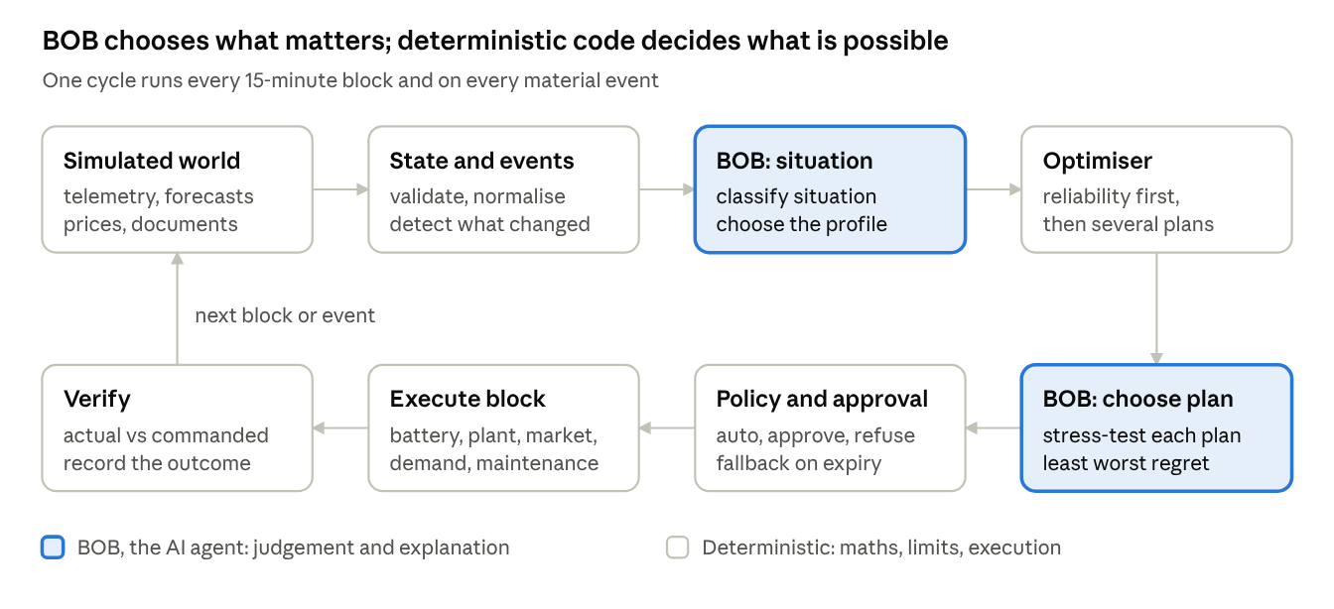
BOB decision cycle · 8 steps, 2 agent decisions
The two highlighted steps are the agent's judgement; every number, limit and command comes from deterministic code, so the loop keeps running if the AI is unavailable.

The problem
A utility running 5 solar farms, 3 wind farms, 2 batteries, industrial consumers and market access must re-decide its operating plan 96 times a day, and every decision trades cost against carbon, curtailment, battery life and grid reliability.
In India each 15-minute block is a settlement unit. The utility has a declared schedule with the grid; any gap between scheduled and actual exchange is charged under CERC's Deviation Settlement Mechanism. Surplus or shortfall can be traded on the exchanges (day-ahead and real-time markets), but only before each market's gate closes.
Within one block, any of these can change at once:
- Clouds cut solar output, or wind ramps up faster than forecast.
- Real-time market prices spike for the evening blocks.
- A battery trips, or a transmission corridor hits its limit.
- An industrial consumer's demand jumps.
- A storm warning or maintenance notice arrives as a document, not as data.
The operator's real question is not "what is each asset doing" but "given everything that just changed, what is the best thing the whole portfolio can do in the next block — and is it safe and allowed?" Answering that by hand, every 15 minutes, across uncertain forecasts and competing goals, is beyond what a control-room shift can do consistently.

How the industry runs this today
Today the decision is split across five tools and three teams, and nobody optimises the portfolio as one system.
Tool or team | What it does well | What it leaves undone
SCADA / plant EMS | Real-time visibility and equipment control per plant | No view of markets, forecasts or other plants; it executes, it does not decide
Forecasting and scheduling services (vendors, QCAs) | Day-ahead and intraday solar, wind and demand forecasts; schedule submission | Deliver forecasts, not decisions; uncertainty bands rarely reach the dispatch choice
Power trading desk | Day-ahead and real-time market bids | Works from spreadsheets and phone calls; sees prices but not battery state or plant limits in real time
Battery EMS | Safe charge/discharge within limits | Usually fixed time-of-day rules (charge midday, discharge evening) that ignore today's prices and forecasts
Commercial DERMS / VPP platforms | Aggregation, optimisation and bidding for large fleets | Costly, long integrations; objective weights are hidden in configuration; cannot read unstructured inputs such as storm bulletins or curtailment orders
The result is a familiar set of losses: deviation penalties when forecasts miss, renewable energy curtailed that a battery could have absorbed, batteries cycled on a fixed clock instead of on price, and demand response used rarely because nobody has time to evaluate it. When objectives conflict, the trade-off is made implicitly by whoever is on shift, and is not recorded.

Our solution
BOB is an AI agent that runs the portfolio's decision loop every 15-minute block and on every material event: it reads the situation, decides which goals matter most right now, asks a deterministic optimiser for alternative plans, picks the one that holds up best under uncertainty, and executes it within policy limits.
The design rests on four ideas.
- The agent decides what matters; the solver does the maths. BOB never computes power flows or approves its own actions. A mixed-integer optimiser (open-source HiGHS) guarantees every plan respects battery, plant, corridor and grid limits. If the language model is unavailable, the loop continues with rule-based choices.
- Optimality criteria change with the situation. BOB classifies the situation and picks one of five vetted objective profiles. Reliability is always solved first and cannot be traded away; the profile then sets how cost, carbon, curtailment, battery wear and schedule deviation are weighed.
- Plans are chosen for robustness, not for the best forecast. For each situation the optimiser produces several plans across the trade-off. Each plan's next-block actions are tested against stress scenarios (solar shortfall, demand surge, battery outage, price spike, storm), and BOB picks the plan with the smallest worst-case regret.
- Autonomy is bounded by policy. Routine actions run automatically. Large trades, big curtailments, demand-response calls and maintenance changes wait for an operator. If an approval expires, a pre-computed fallback plan runs instead. Unsafe actions are refused and logged.
Objective profile | When BOB selects it | What it favours
Balanced | Normal operation | Cost and carbon evenly, moderate battery reserve
Economic | Wide price spread or a price spike ahead | Market value; battery held for high-price blocks
Clean | Renewable surplus, low prices | Renewable utilisation; minimal curtailment
Resilience | Storm alert, asset outage or thin reserve | Higher battery reserve; less market exposure
Grid support | Frequency stress or corridor congestion | Tight schedule tracking; headroom for fast response
BOB also reads what tables cannot carry. An operator can drop in a storm bulletin, a maintenance email or a grid operator's curtailment order (text, PDF or image). BOB extracts a typed constraint with the quoted source line. A constraint that only makes the system more cautious applies at once; anything that relaxes a limit waits for a human.

How it meets the brief
Every feature and depth requirement maps to something a judge can see working in the demo.
Requirement | How BOB answers it | Where it shows in the demo
F1 — optimal cluster of actions | One coordinated plan per block: battery, market, curtailment, demand response and maintenance actions together | Control Room: "actions this block"
F2 — options after choosing criteria, under uncertainty | Situation → objective profile → several plans across the trade-off → regret test against stress scenarios → chosen plan with its reason | Decision view: trade-off chart, plan × scenario heat map, BOB's rationale
F3 — simulate over time with varying inputs | The same loop replayed over 96 blocks, across many random variations of forecast error, outages and prices; BOB versus today's rule-based practice | Scenario Lab: outcome distributions per metric
D2 — high, demonstrable reliability | A fixed test set of seeded runs proves zero hard-limit violations, correct fallbacks when the AI or solver fails, and tool-call success rates | Scenario Lab: reliability report
D3 slice — heterogeneous inputs | Storm bulletins, maintenance notices and curtailment orders read from text, PDF or image into typed constraints, checked against a labelled sample set | Documents inbox: extraction with quoted source and confidence
The brief's action list is covered in full: charge, discharge and reserve battery capacity; buy, sell and delay selling; curtail wind or solar; trigger demand response, cut non-critical load and shift industrial load; schedule or delay maintenance and dispatch inspection teams.

Productivity: from monitoring to managing exceptions
BOB moves the operator from watching every block to approving the few decisions that need human judgement, so the same team can run a larger portfolio with fewer misses.
Task | Today | With BOB
Reacting to a forecast change | Operator notices, calls the trading desk, adjusts battery manually | Event detected, re-planned and next-block actions executed automatically within policy
Deciding battery use | Fixed charge/discharge clock, revised weekly | Re-optimised every block against prices, forecasts, reserve needs and the warranty cycle budget
Real-time market trading | Spreadsheet estimate before each gate closure | Bid quantities proposed with expected value; small bids automatic, large bids one-click approval
Weighing conflicting goals | Implicit, depends on who is on shift, unrecorded | Explicit profile and trade-off chart; every choice recorded with its reason
Handling a storm bulletin or curtailment order | Read, interpret, re-plan by hand | Read by BOB, turned into a constraint with the source quoted, applied or queued for confirmation
Planning maintenance | Fixed calendar; outages often fall in high-value windows | BOB proposes the lowest-value window before each deadline; safety-critical work never delayed
Post-event review | Reconstruct from logs and chat messages | Decision timeline links each action to its inputs, plan, approval and measured result
The operator's job becomes: review approvals, confirm document-derived constraints, and question BOB in plain language ("what if BESS-2 stays down until 18:00?"). Each question is answered by the same optimiser, not by the language model's guess.

Portfolio efficiency versus current models
The gain comes from treating the portfolio's flexibility (batteries, flexible load, market access, curtailment) as one shared resource, re-optimised every block under uncertainty, instead of as separate tools run on fixed rules.
Capability | Rule-based practice today | Commercial DERMS / VPP | BOB
Decision scope | Per asset, per team | Portfolio | Portfolio, including maintenance timing and demand response
Uncertainty | Single forecast | Often probabilistic | P10/P50/P90 forecasts plus stress scenarios; plans chosen by worst-case regret
Conflicting objectives | Implicit | Fixed weights in configuration | Situation-dependent profile, shown as a trade-off chart with the reason
Unstructured inputs | Read by people | Not handled | Read by BOB into constraints, with source and confidence
Deviation penalties | Absorbed after the fact | Usually modelled | Priced in every block's plan and tracked as a metric
Battery life | Fixed cycles | Degradation cost | Degradation cost plus a hard warranty cycle budget
Explainability and audit | Logs and memory | Varies | Every decision traceable from inputs to measured result
Cost to run | Staff time | Licence plus integration | Open-source solver on CPU; the language model is called only when the situation changes
How we prove it. We do not quote savings we have not measured. Scenario Lab replays the same simulated days under two policies — today's practice (schedule equals the median forecast, battery on a fixed clock, manual trading) and BOB — across many random variations, and reports the difference on these metrics:
- Net operating cost (₹): purchases, sales, deviation charges, demand-response payments, curtailment compensation and battery wear.
- Deviation from schedule (MWh) and deviation charges (₹).
- Renewable utilisation (%) and curtailment (MWh), separating unavoidable from avoidable curtailment.
- Carbon (tCO₂) from grid imports, using the CEA grid emission factor.
- Unserved energy and reserve shortfall (MWh): the target is zero.
- Battery cycles used against the warranty budget.
- Hard-limit violations: must be zero in every run.

Demo story
The judges watch one simulated day unfold at accelerated speed, with each change injected live and BOB's response visible within the same block.
Sim time | What changes | What BOB does | What it proves
11:00 | Normal day, midday solar surplus, low prices | Balanced profile; charges batteries, sells surplus, holds evening reserve | F1 coordinated plan; beats the fixed-clock baseline
11:07 | Cloud bank: solar forecast down 30% for an hour | Re-plans mid-block; switches to discharging, revises a real-time market buy before gate closure | Event-driven re-planning under uncertainty
11:10 | Evening real-time prices spike | Economic profile; keeps stored energy for the spike instead of selling now ("delay selling") | Intertemporal value of storage; criteria change with the situation
11:12 | BESS-02 trips | Re-optimises with BESS-01, flexible load and the market; asks approval for a demand-response call | F2 alternatives; policy-gated autonomy
11:14 | North corridor reaches its limit | Grid-support profile; cuts wind export, stores what it can, curtails only the unavoidable remainder | Network-aware feasibility; curtailment as last resort
11:15 | Next block starts | Executes block actions, then compares commanded against actual and records any deviation | Closed loop with verification
11:20 | Operator uploads an IMD-style storm bulletin (PDF) | Extracts a storm-risk constraint with the quoted line; resilience profile raises battery reserve; proposes delaying wind maintenance and dispatching an inspection after the storm | D3 slice; maintenance actions
Afterwards | Scenario Lab runs the full day across random variations | Shows BOB against today's practice per metric, plus the reliability report | F3 and D2 evidence

Scope, assumptions and limits
The demo is a complete decision system running against a simulated world; only the connections to real equipment and markets are mocked.
Simulated, and configurable per scenario: weather and forecasts (with realistic errors that grow with lead time), solar and wind output, industrial demand, exchange prices, grid frequency, emission factors, and the responses of battery systems, plant controllers, the market, consumer energy systems and the maintenance system (including delays, rejections and partial delivery).
Simplifications, stated openly:
- Deviation charges follow the structure of the CERC DSM Regulations 2024 with simplified, configurable rates.
- India has no carbon price on electricity yet; carbon uses a configurable shadow price.
- The network is a corridor model (nodes and line limits), not a full power-flow study.
- Frequency is a planning signal (reserve headroom, schedule tracking). Fast frequency response stays with the plant's own controllers.
Out of scope: replacing SCADA, plant EMS, battery management or market settlement; protection and sub-second control; building our own weather forecasts.
Path to production: replace each mock with a real adapter (IEC 61850 or IEC 60870-5-104 via SCADA, exchange APIs, the grid operator's scheduling portal, a CMMS). Start in advisory mode behind a protected network zone, in line with CEA's cybersecurity guidelines. Everything above the adapters stays the same.

